**FINAL SQL PROJECT**

**Submitted By – SUNIDHI RAWAT**

1. Write a query to display the names (first_name, last_name) using alias name “First Name", "Last Name"

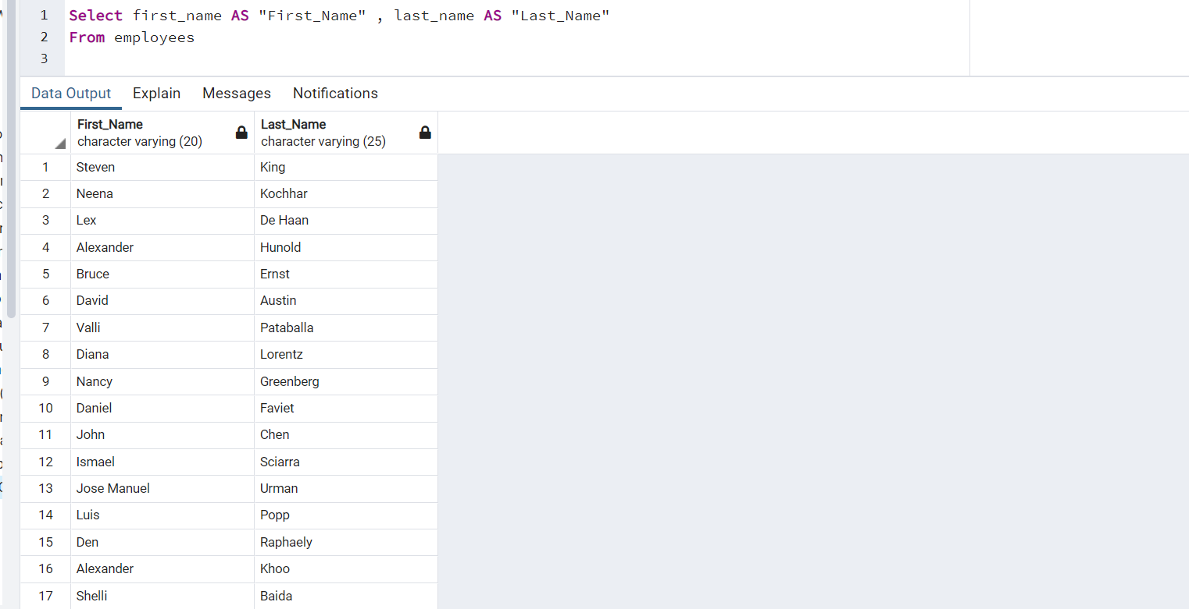

2. Write a query to get unique department ID from employee table

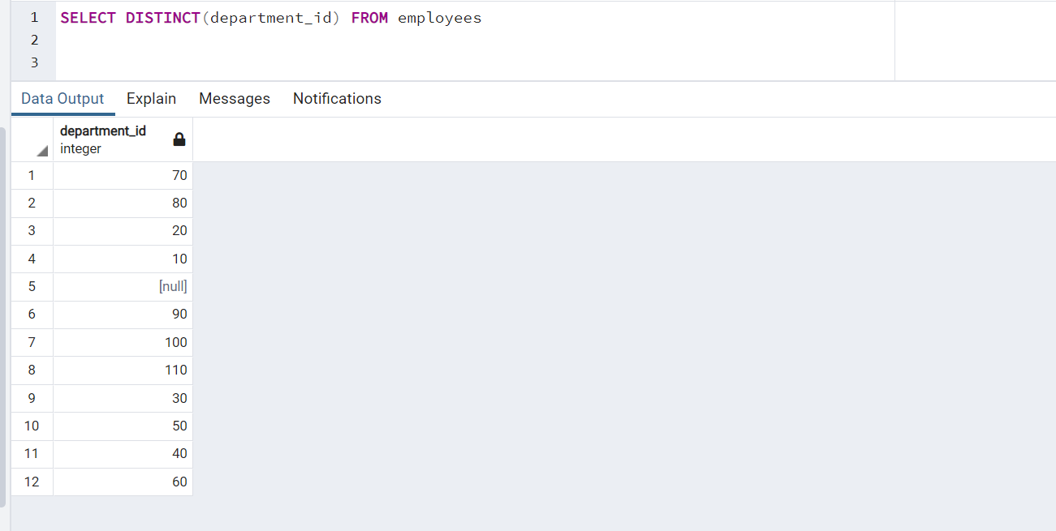

3. Write a query to get all employee details from the employee table order by first name, descending

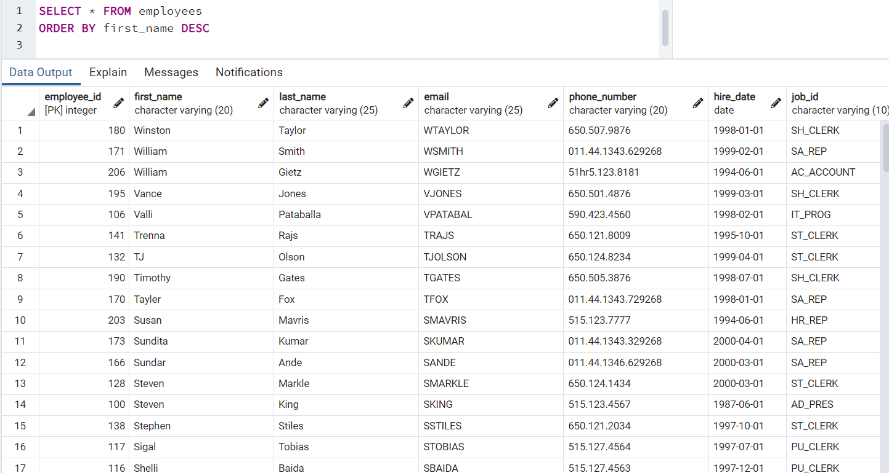

4. Write a query to get the names (first_name, last_name), salary, PF of all the employees (PF is calculated as 15% of salary)

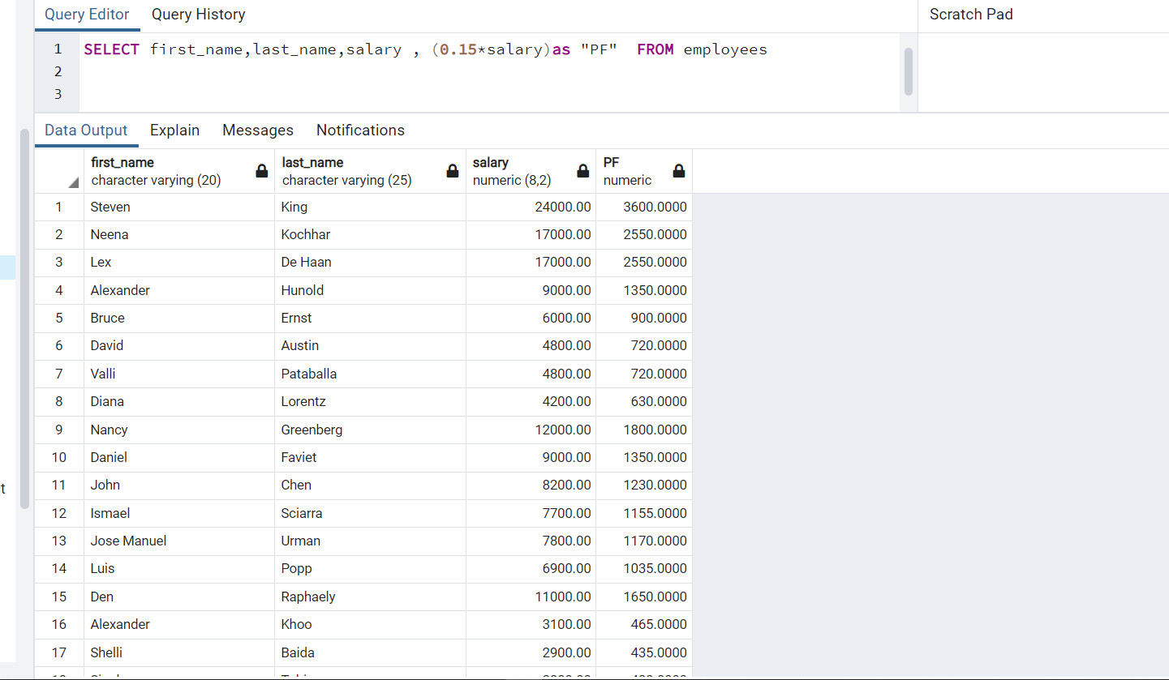

5. Write a query to get the employee ID, names (first_name, last_name), salary in ascending order of salary

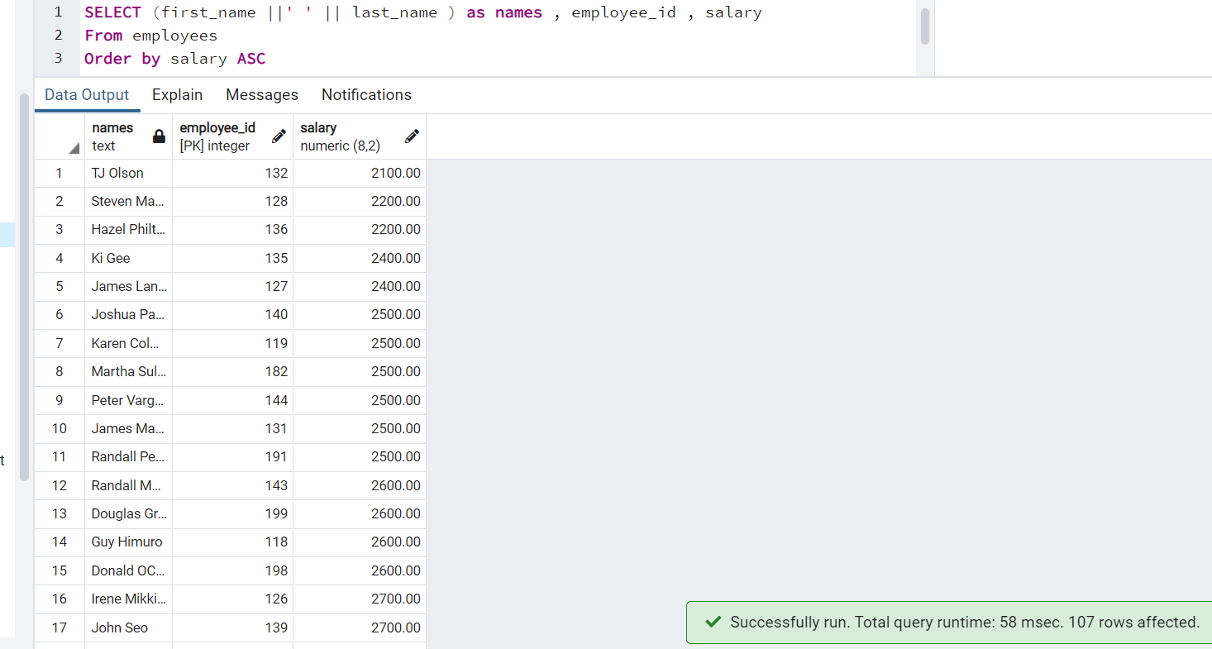

6.  Write a query to get the total salaries payable to employees

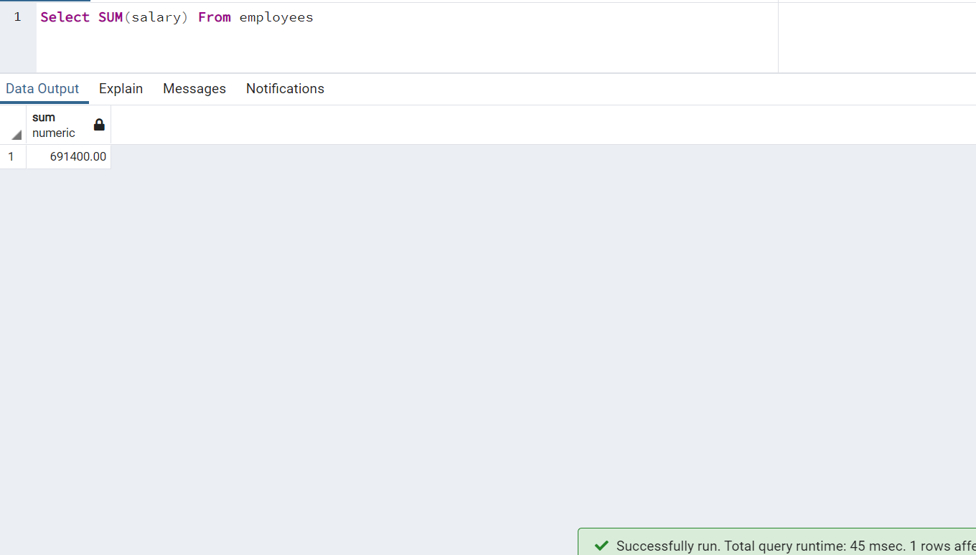

7. Write a query to get the maximum and minimum salary from employees table

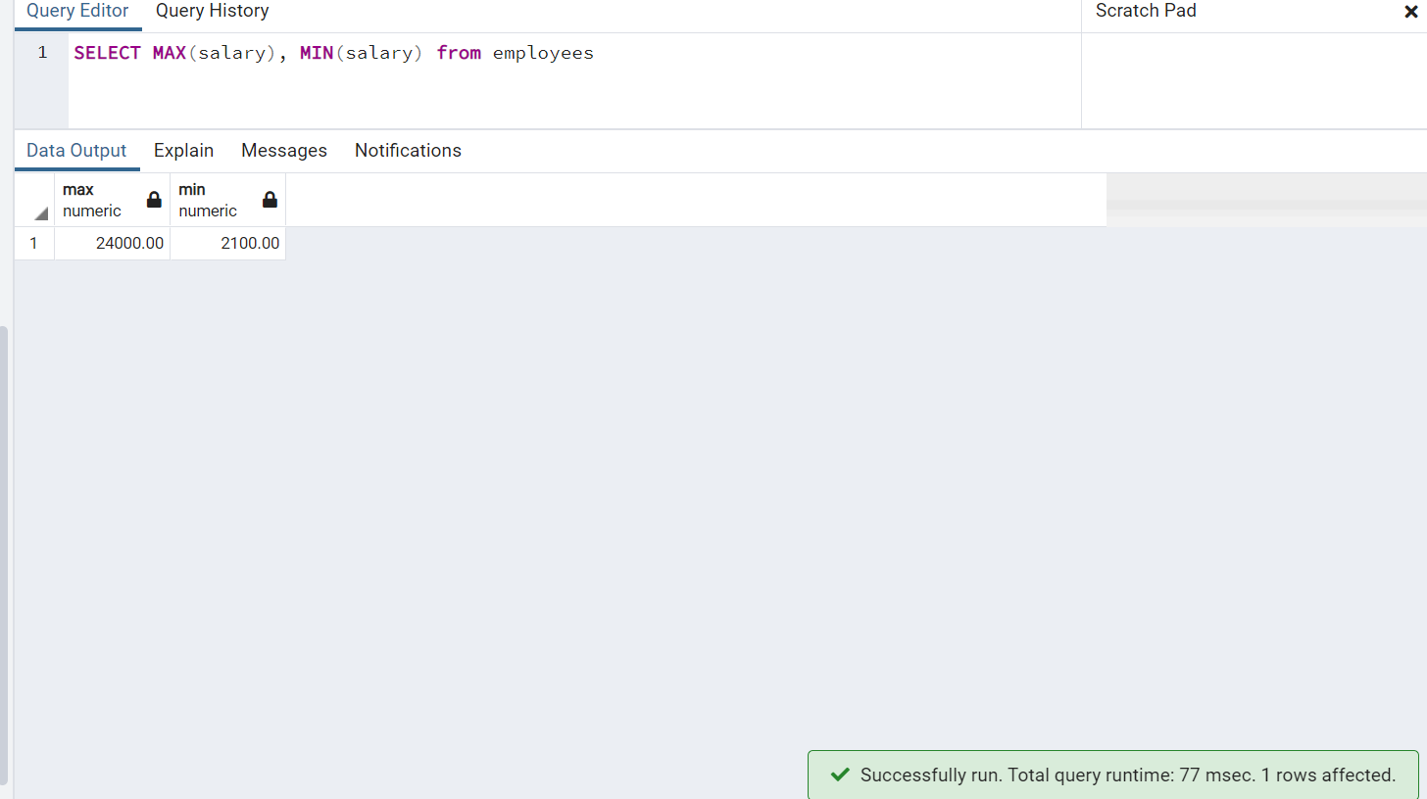

8. Write a query to get the average salary and number of employees in the employees table

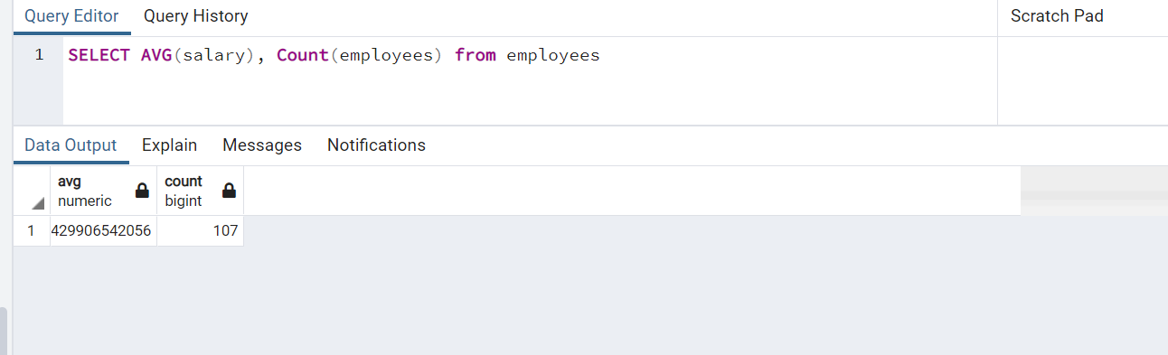

9. Write a query to get the number of employees working with the company

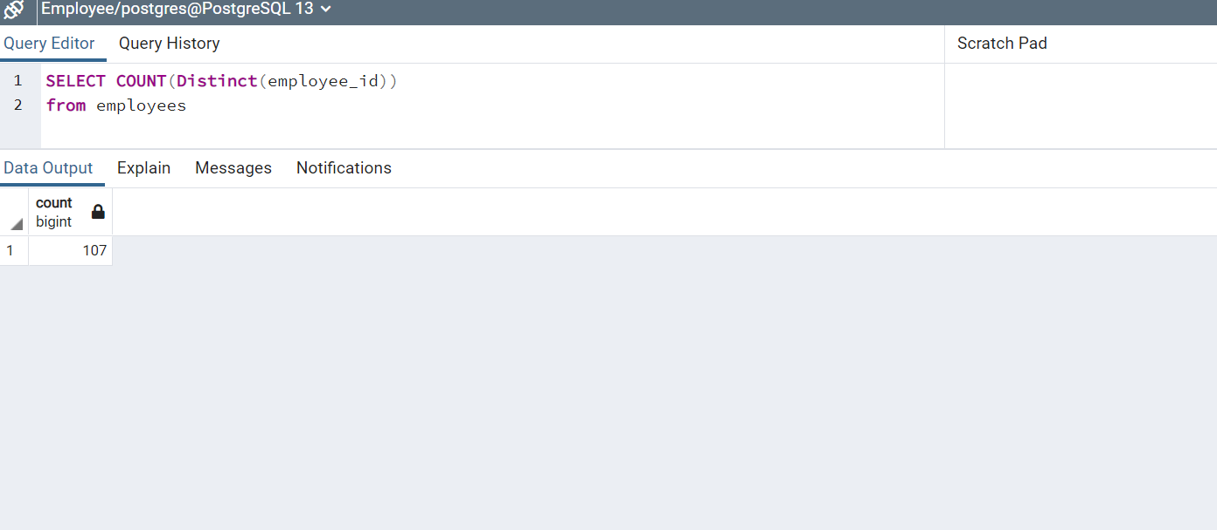

10. Write a query to get the number of jobs available in the employees table

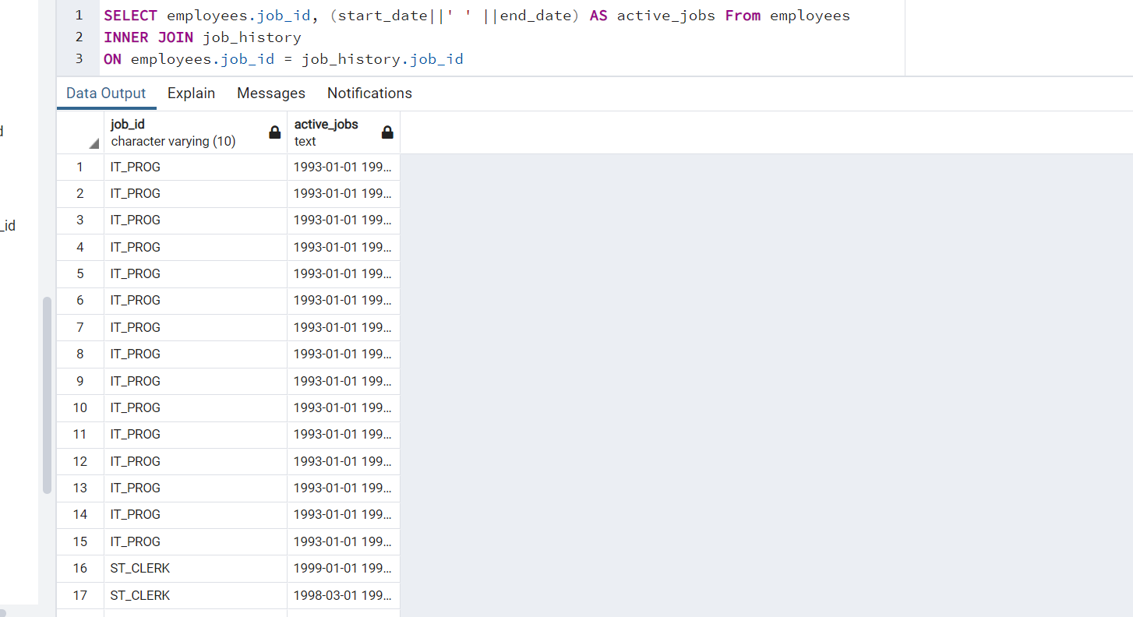

11. Write a query get all first name from employees table in upper case

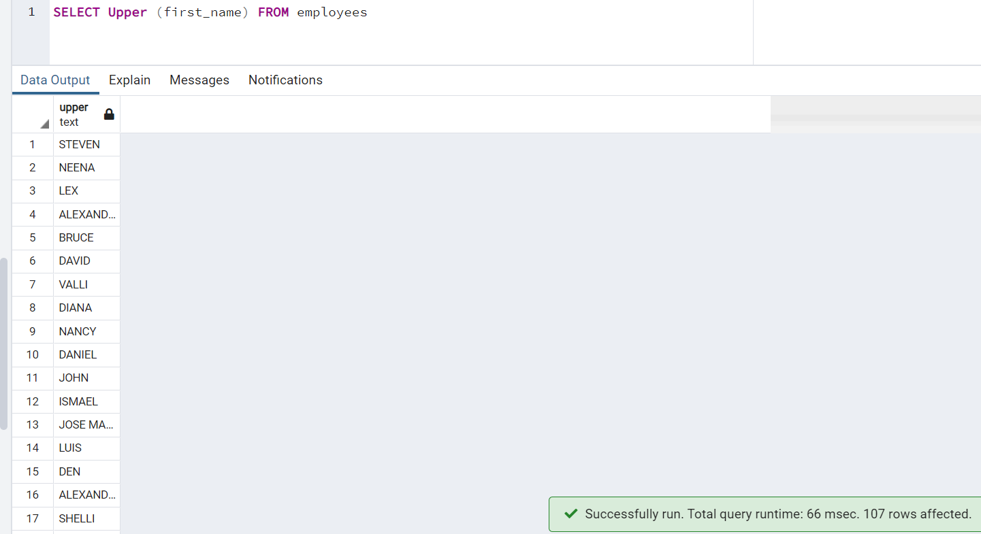

12. Write a query to get first name from employees table after removing white spaces from both side

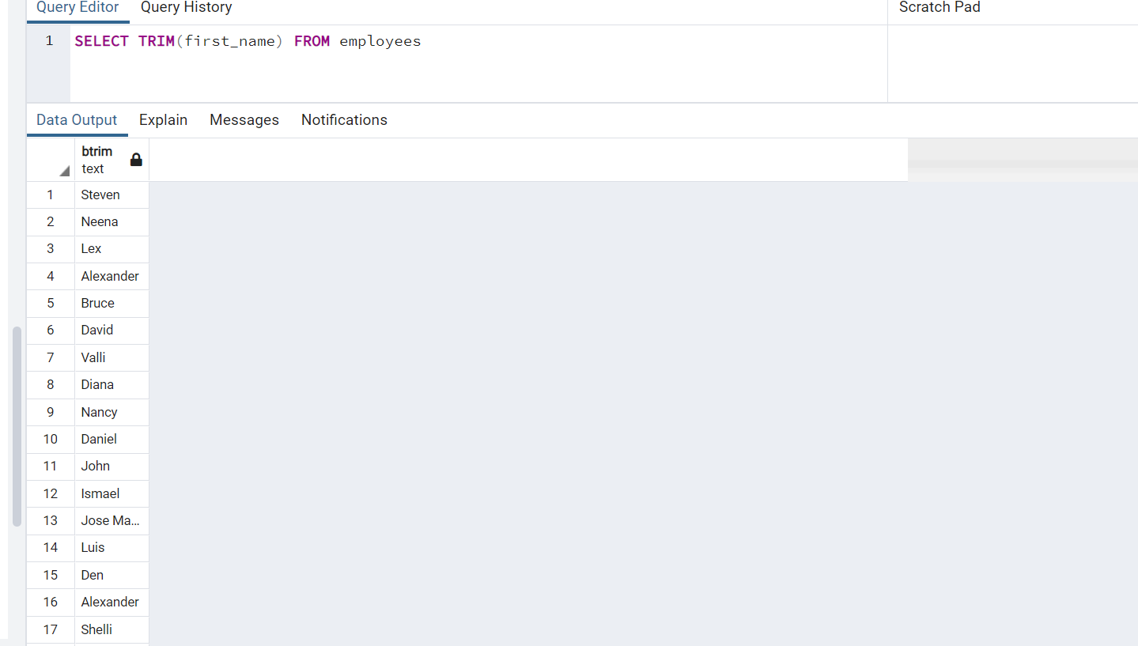

13. Write a query to get the length of the employee names (first_name, last_name) from employees table

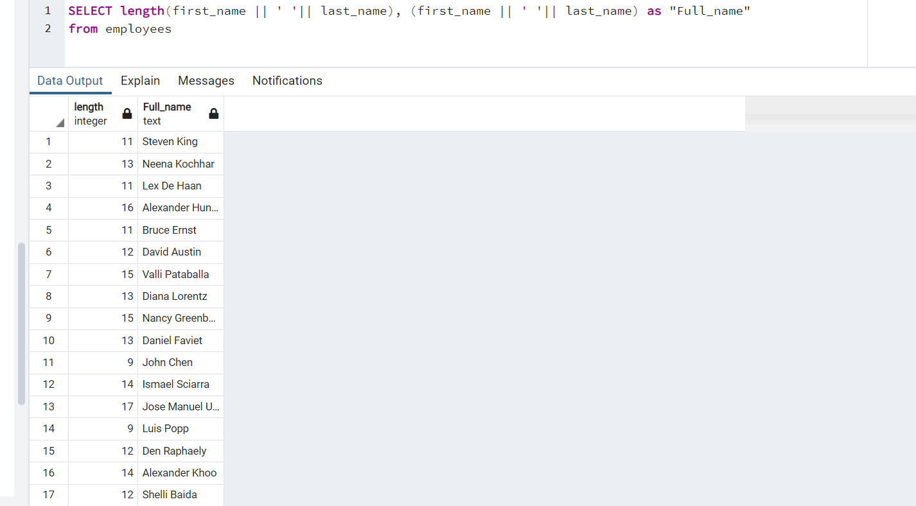

14. Write a query to display the name (first_name, last_name) and salary for all employees whose salary is not in the range $10,000 through $15,000

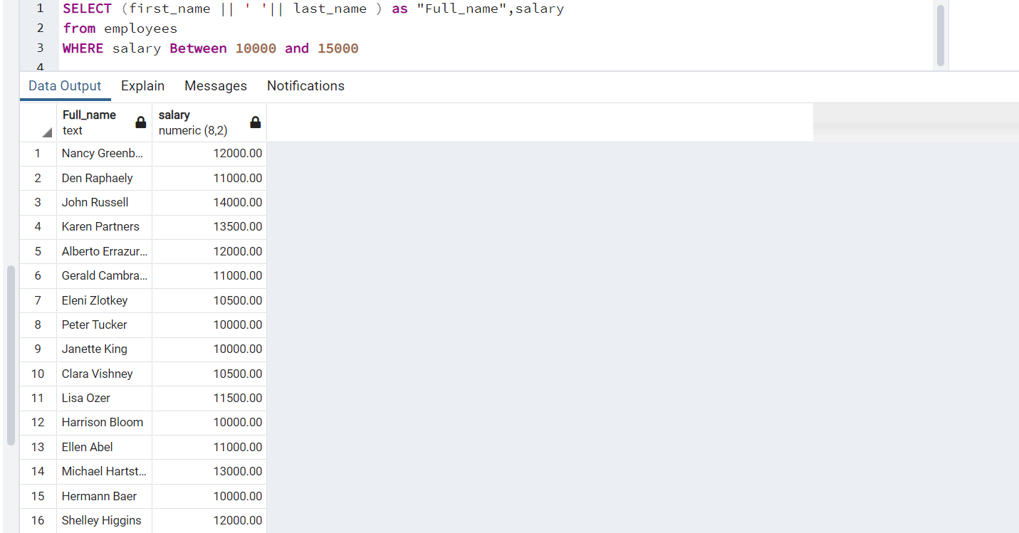

15. Write a query to display the name (first_name, last_name) and salary for all employees whose salary is not in the range $10,000 through $15,000 and are in department 30 or 100

